Parth Babbar

9999940289  kishibabbar@gmail.com

banks in United states

**Introduction:**

The banking system in the United States is a complex and diverse network of banks that provide a wide range of banking services for individuals, corporations, and governments. Each type of bank is subject to various rules and provides unique services, income structures, and client interaction approaches. Understanding the many types of banks and their roles may help people and organisations make wiser choices regarding finances. This document gives a review of the many types of banks in the United States.

**Types of banks:**

The US banking system comprises various types of banks, each serving different functions:

1. **Commercial Banks:** Commercial banks are the most popular form of bank in the United States, offering a variety of financial services to people, businesses, and governments. They serve an important role in the economy by enabling daily financial transactions and offering loans for personal and corporate use.  
     
   Key Features of Commercial Banks:  
   **1. Services:** Commercial banks offer a wide range of banking services, including checking and savings accounts, personal and business loans, credit cards, mortgage loans, and investment options.  
   **2. Revenue Generation:** Their primary revenue sources include loan and mortgage interest, account service fees, and transaction fees.  
   **3. Customer:** Commercial banks serve a wide range of customers, from individuals to small enterprises and major organisations. They usually provide wide branch networks and online banking systems to improve consumer accessibility and convenience.  
   **4. Regulatory Supervision:** The Office of the Comptroller of the Currency (OCC), the Federal Reserve, and state banking authorities all oversee the industry.  
   **5. Size:** As of 2023, commercial banks comprised over 4089 banks in the US, and the assets were $23.4 trillion.  
   **6. Examples:** Major examples are JPMorgan Chase, Bank of America, Wells Fargo, and Citibank.  
     
   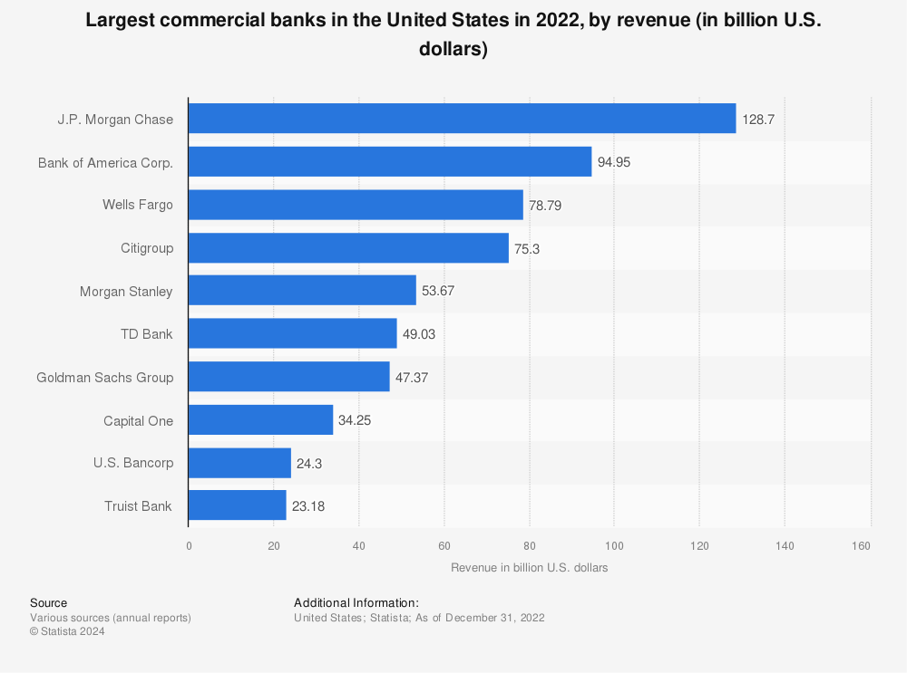
2. **Investment Banks:** Investment banks focus on large and complex financial transactions, including securities and merger and acquisition advice services. They do not provide standard banking services such as receiving deposits or making personal loans.  
     
   Key features of Investment Banks:  
   **1. Services:** They provide a variety of financial services, including securities underwriting, mergers & acquisitions advising, asset management, securities trading, and investment research.  
   **2. Revenue Generation:** They earn revenue by charging for advisory services, underwriting fees, trading commissions, and earnings from proprietary trading.  
   **3. Customer:** They primarily serve large enterprises, institutional investors, and governments. They specialise in high-value transactions and financial advice.  
   **4. Regulatory Supervision:** The Securities and Exchange Commission (SEC) and the Financial Industry Regulatory Authority (FINRA) oversee its operations.  
   **5. Size:** Goldman Sachs, Morgan Stanley, and JPMorgan Chase are the biggest three investment banks in the United States, managing trillions of dollars in assets.  
   **6. Examples:** Goldman Sachs($538billion), Morgan Stanley($1.228trillion), JPMorgan Chase($3.38trillion), and Bank of America($2.4trillion) are among the most well-known investment banks.  
   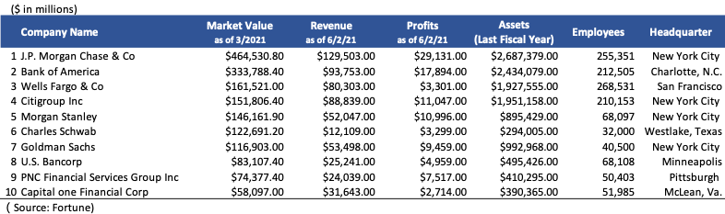
3. **Credit Unions:** Credit unions are member-owned financial cooperatives that offer a variety of banking services. As not-for-profit organisations, they seek to return earnings to their members through cheaper rates and fees.  
     
   Key features of Credit Unions:  
   **1.⁠ ⁠Services:** Provides savings and checking accounts, personal loans, mortgages, credit cards, and financial advice.

**2.⁠ ⁠Revenue Generation:** Earns money mostly from loan interest and minor service costs. Profits are distributed to members as dividends or decreased interest rates.

**3.⁠ ⁠Customer:** Membership-based, frequently restricted to certain communities, companies, or organisations. Members actively participate in the credit union's decisions and benefit from favourable financial arrangements.

**4.⁠ ⁠Regulatory Supervision:** The National Credit Union Administration (NCUA) oversees this organisation.

**5.⁠ ⁠Size:** As of 2022,credit unions consisted of 4760 unions with 135.3 million members and consisted of over $2trillion of assets.

**6.⁠ ⁠Examples:** Major examples are Navy Federal Credit Union($168.4billion), State Employees’ Credit Union($50.68billion), Pentagon Federal Credit Union ($35.36billion), Alliant Credit Union($18.94billion).  
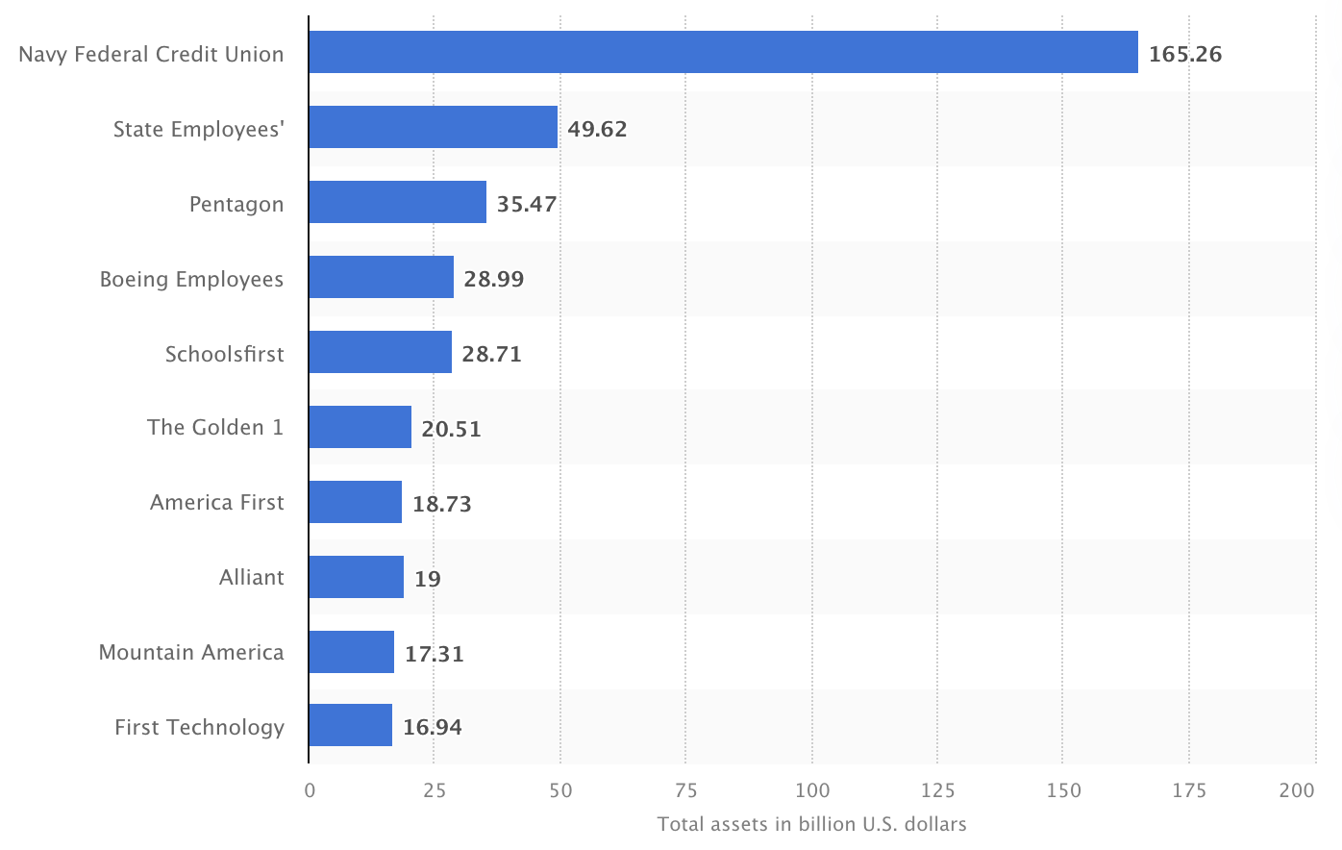

1. **Saving and Loan Associations:** Savings and loan associations, sometimes known as thrift institutions, specialise in receiving savings deposits and issuing mortgage loans. Their principal goal is to encourage homeownership.  
     
   Key features of Saving and Loan Associations:  
   **1. Services:** Savings accounts, mortgage loans, and sometimes personal loans and checking accounts.

**2. Revenue Generation:** Mortgage loan interest and savings account fees are the primary sources of revenue.

**3. Customer:** Focus on individuals searching for savings options and home loans. They frequently provide excellent rates on savings and housing loans.

**4. Regulatory Supervision:** Previously governed by the Office of Thrift Supervision (OTS), but currently overseen by the OCC and the Federal Reserve.

**5. Size:** As of 2023,565 associations were part of it with a total of over $1trillion assets.

**6. Examples:** Major examples are New York Community Bank, Astoria Bank, Washington Federal. 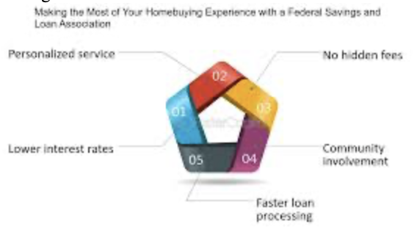

1. **Community Banks:** Community banks are locally owned by financial organisations that value personal ties with their clients. They prioritise meeting the requirements of their local community and small companies.  
     
   Key feature of Community Banks:  
   **1. Services:** Checking and savings accounts, personal and commercial loans, mortgages, and even wealth management services.

**2. Revenue Generation:** Earn money from loan interest, service fees, and community participation initiatives.

**3. Customer:** Serve local residents and small businesses, with a focus on customer service and community participation.

**4. Regulatory Supervision:** Regulated by state banking authorities, the OCC, and the Federal Reserve.

**5. Size:** As of 2023,it consisted of 4429 banks across 50 states an d all banks have less than $10billion in assets.

**6. Examples:** Major examples are Community Bank, N.A., Eastern Bank, Pinnacle Bank, First Citizens Bank.

1. **Central Banks:** As the United States' central bank, the Federal Reserve supervises and regulates the country's banking system, sets monetary policy, and promotes financial stability. It does not provide banking services to the public.  
     
   Key features of Central Banks:  
   **1. Services:** Implements monetary policy, supervises and regulates banks, and offers financial services to the government and other financial entities.

**2. Revenue Generation:** Revenue is generated from interest on government securities and fees for services given to financial institutions.

**3. Customer:** Serves the federal government, financial institutions, and ensures financial stability for the whole economy.

**4. Regulatory Supervision:** Operates under congress authority and is overseen by several federal committees.

**5. Size:** The Federal Reserve handles monetary policy for the United States economy and has assets worth more than $7.284 trillion.

**6. Examples:** The Federal Reserve System  
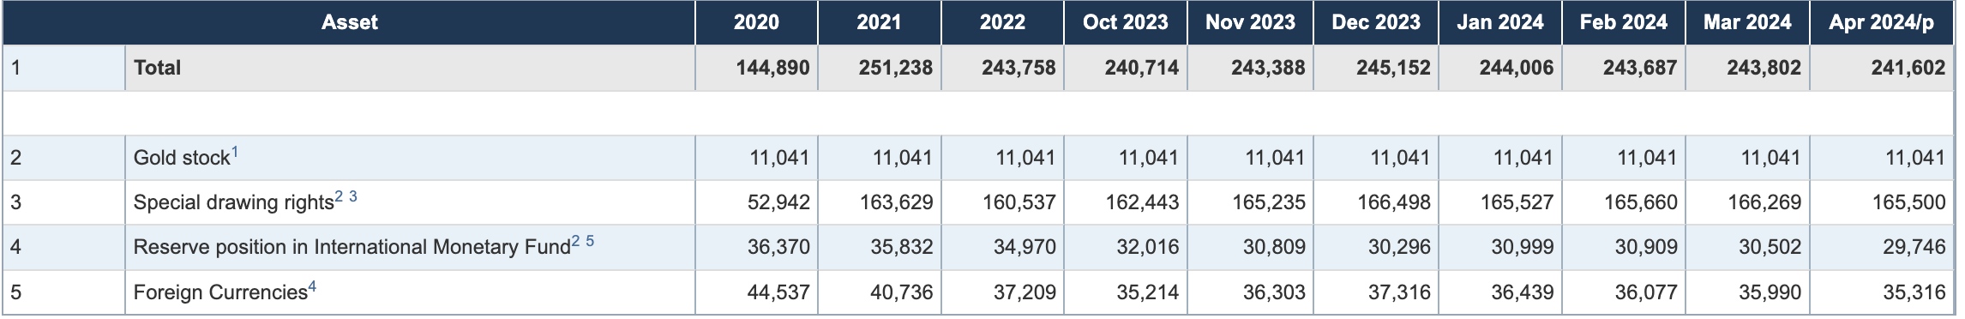

1. **Online Banks:** Online banks operate only on the internet, offering standard banking services without physical locations. They use technology to minimise operating expenses and frequently provide competitive rates and cheaper fees.  
     
   Key features of Online Banks:  
   **1. Services:** Checking and savings accounts, personal loans, credit cards, and occasionally investment goods.

**2. Revenue Generation:** Earn revenue from loan interest, service fees, and fewer administrative expenses, which can occasionally result in higher deposit interest rates.

**3. Customer:** Attract tech-users clients that value online banking and the ease of 24/7 access. They frequently provide user-friendly mobile applications and websites.

**4. Regulatory Supervision:** According to its constitutions, they are regulated by the OCC, the Federal Reserve, and state banking regulators.

**5. Size:** Online banks such as Ally Bank and Capital One 360 have rapidly expanded, managing assets worth tens of billions of dollars.

**6. Examples:** Major examples are Ally Bank, Capital One 360, Discover Bank, Chime.

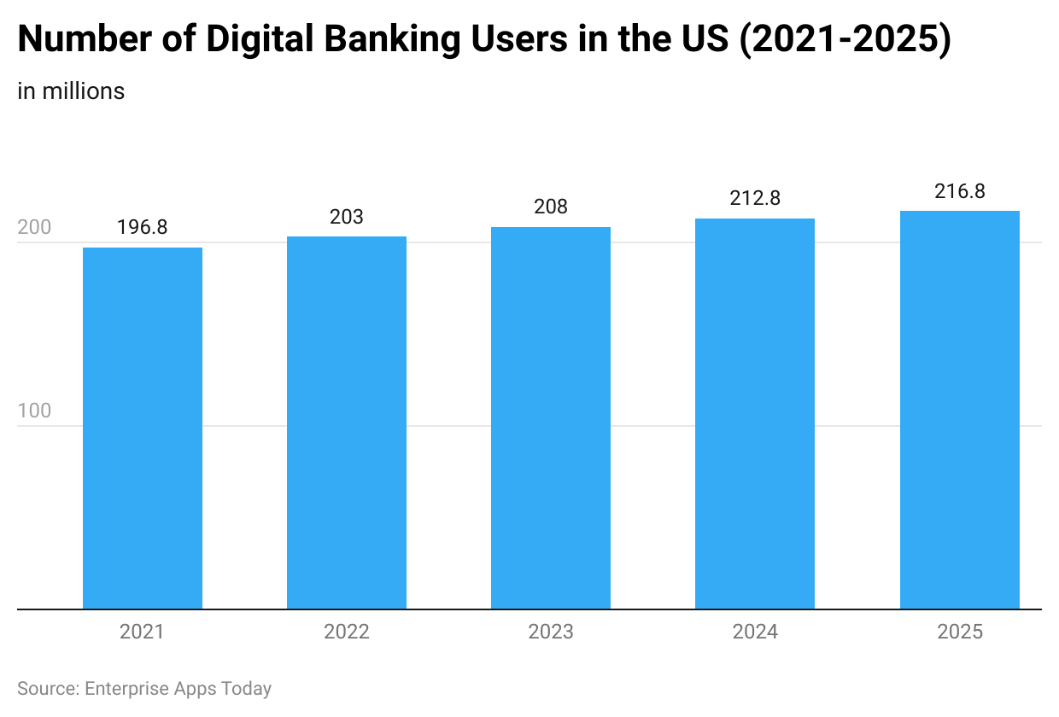

**Conclusion:**

The banking system in the United States is diverse, with banks providing a  wide range of financial demands and consumer sectors. From big commercial banks that provide a wide variety of services to specialised institutions such as credit unions and industrial banks, each kind of bank serves a distinct role in the financial ecosystem. Understanding the differences between these banks can help people and businesses select the best institution for their financial requirements.